Challenge: Trapped Source

# Challenge Description :

**The Intergalactic Ministry of Spies tested Pandora's movement and intelligence abilities. She found herself locked in a room with no apparent means of escape. Her task was to unlock the door and make her way out. Can you help her in opening the door?**

# Context :

## This one is really easy, you basically just need a browser to finish this.

# Notes :

* Tools:
  + - Browser - A browser like chrome, firefox, brave, librewolf.

# Challenge :

* Basic analysis on a web-page.

# Flag :

* Start the instance, go to the website and open the Inspect-element prompt, and head to the elements page, you might need to refresh but basically the code should be there.
* After entering the Correct Pin you should get a flag at the top.

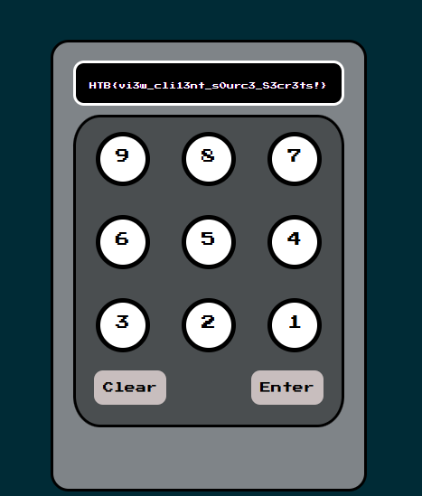

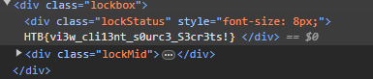

We get the flag : HTB{vi3w_cli13nt_s0urc3_S3cr3ts!}